

**ECE 1778 - Creative Applications for Mobile Devices**

**Final Report**

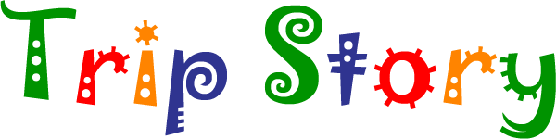

Saher Samnani - (Specialist)

Ayazhan Zhakhan - (Programmer)

Shuja Khalid - (Programmer)

**Table of Contents:**

[**1. Introduction (Specialist Context**](https://docs.google.com/document/d/18odhABfSi3qdBrJreyhvC2E-ix_X83z6QeGYK8DGKBY/edit#heading=h.93sccxjky633)**) 3**

[**2. Statement of Functionality & Screenshots**](https://docs.google.com/document/d/18odhABfSi3qdBrJreyhvC2E-ix_X83z6QeGYK8DGKBY/edit#heading=h.9vr75qfk4q5u) **3**

[**3. Overall Design**](https://docs.google.com/document/d/18odhABfSi3qdBrJreyhvC2E-ix_X83z6QeGYK8DGKBY/edit#heading=h.sdxy7urksgb) **(Block Diagram) 12**

[**4. Reflection**](https://docs.google.com/document/d/18odhABfSi3qdBrJreyhvC2E-ix_X83z6QeGYK8DGKBY/edit#heading=h.8cxbi94us6xg) **13**

[**5. Individual Contribution**](https://docs.google.com/document/d/18odhABfSi3qdBrJreyhvC2E-ix_X83z6QeGYK8DGKBY/edit#heading=h.uz64psuddbx3) **13**

[**6. Future Work**](https://docs.google.com/document/d/18odhABfSi3qdBrJreyhvC2E-ix_X83z6QeGYK8DGKBY/edit#heading=h.xhaak0ze1ti9) **15**

[**7. Group Consent**](https://docs.google.com/document/d/18odhABfSi3qdBrJreyhvC2E-ix_X83z6QeGYK8DGKBY/edit#heading=h.bjkeli233foi) **16**

1. Introduction (Specialist context)

The aim of the project- ‘Trip Story’ is to create a Rebus Story (picture story) App that allows children to form their personalized stories by answering a series of questions. These questions are designed to be engaging and test the user’s (children age: 4+) creativity. The App provides a platform for the child to create their own stories with assistance from the parent. Upon making the correct selection, the story would continue and finally the story formed will be portrayed in the form of a Rebus story.

The ‘Rebus story’ concept aims to promote early literacy by motivating children to participate in storytelling while also improving cognitive skills. The App thus caters to preschool children in improving their cognitive and literacy skills and is a useful asset in the field of education. The preschool years are a signiﬁcant period of pre-reading development, in which children establish foundational skills in the areas of language (e.g., vocabulary, grammar) and literacy (e.g. print knowledge, phonological awareness) because pre-schooler’s language and literacy skills are critically related to later academic success. The App makes reading fun, entertaining, and help children develop a love of reading. The App aims at providing children with a path to create their own stories and personalize it so as to make it engaging. Decision making, speech development and early reading skills, are primary aspects of this App. The App is built on the premise of providing beginning readers, the thrill of learning or creating a story which builds confidence and supports them on their way to independence and becoming self-learners and inquirers. Learning to make their own choices helps children be more independent, responsible, and confident, so decision-making is a good skill to develop at an early stage. The famous psychologist Piaget states that children are "little scientists," actively trying to make sense of the world rather than simply soaking up information passively. Their mind is thus stimulated as they think and question through their options while creating their personalised stories. Children who particularly need to develop literacy skills can really improve and gain confidence and interest in reading using this App. Images, animations, pictures and colours fascinate children and thus a typical child’s story book has big images and very few words. The child can learn to read by identifying their selected pictures in the App as cues as they read along with the parent. Viewing the glossary after each story can reinforce literacy and they can learn the words which adds to the educational value. Parental involvement is another important feature of the App that contributes to a child’s learning and development. Children with parents who are involved in their education and learning tend to have fewer behavioural problems and better academic performance and more likely to complete high school than children whose parents are not involved in their learning process and schooling. Moreover positive feedback from parents encourages children to repeat good behaviour and motivates them to learn more. The App is therefore an enriching tool that nurtures preschool children to simply enjoy reading, learning, thinking, being confident about their capabilities and encourage them to learn more.

2. Statement of Functionality & Screenshots

2.1 What Worked:

The following functionality was added to the application to create a dynamic and user-friendly environment:

2.1.1 Main Menu:

The main menu consists of a simple layout that contains three buttons that can be used to create a story, launch the personalizer view or read a previously created story. The layout of this menu was created with the target demographic in mind which includes young children (Ages 4+).

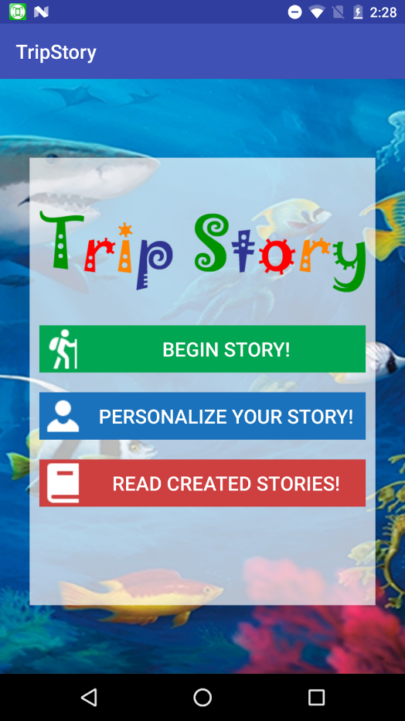

Figure 2.1.1: Screenshot of the Main Menu

2.1.2 Story Personalizer:

The Story Personalizer is an attempt to engage users in the environment by having them become a part of the story. Every frame that they go through will include their snapshot so that they feel as though they are a part of the story and are on an actual adventure. The image is also used in the final story compilation which associates the user with their created story.

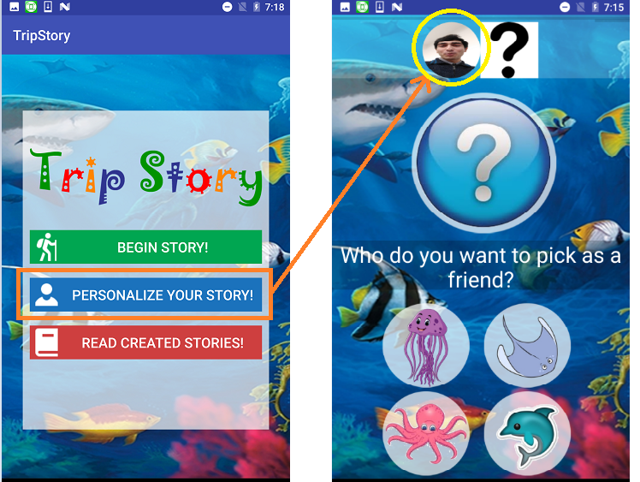

Figure 2.1.2: Screenshot of the Story Personalizer

2.1.3 Theme Selector:

The User can choose a theme for their adventure from this frame. Current themes include Underwater Adventure and Jungle Book. These themes are related to existing movies and cartoons that are popular amongst children. This particular layout is an attempt to make Trip Story modularized so that in the future when more stories/adventures are added, they can be accessed from this frame.

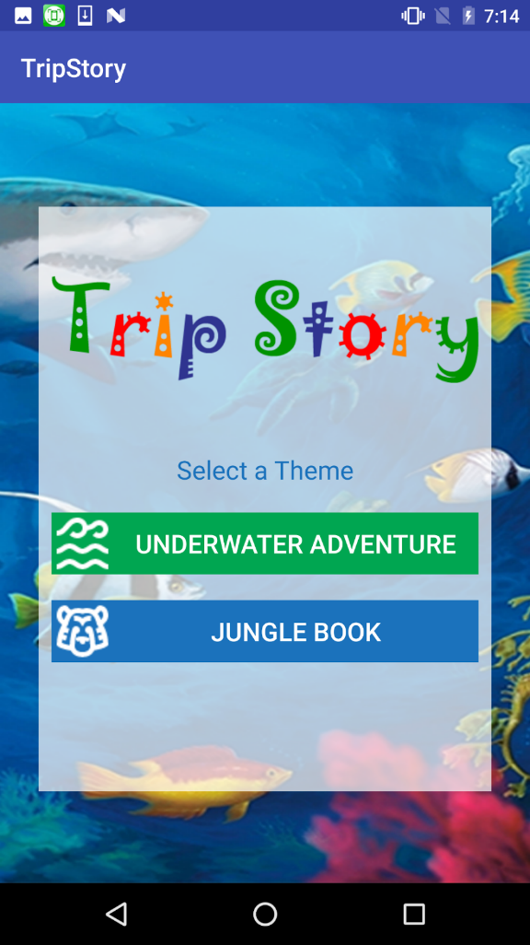

Figure 2.1.3: Screenshot of the Theme Selector

2.1.4 Storyline View:

The process of creating a story begins with this frame. Users are posed with a question and are given four options. There is no correct choice and the decisions are left to the user’s imagination. Each choice is used to create a unique story. A lot of deliberation was put into the design of this View to make the experience more engaging for users. The size of the icons and the layout of elements on the screen were decided upon by consultation with the group’s Specialist and only implemented when each member of the group agreed with the result. Animations were also selectively inserted to capture the imaginations of the user and to make the app more interactive.

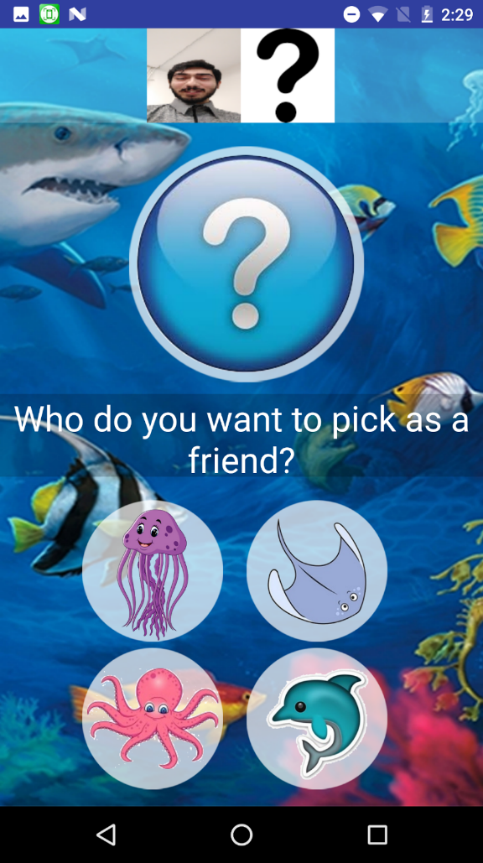

Figure 2.1.4: Screenshot of the Storyline View

2.1.5 Story Compiler:

Once the user makes their way through 15 frames of the storyline View, they are presented with a compilation of their storyline and their choices in a form that can be shared with friends and family in the future. This scrollable form of the story is simply a summary of the previous selections. However, users are encouraged to access their newly created stories from the Rebus Story Library in order to save their stories to online storage and to ensure that they always have a copy of their child’s story!

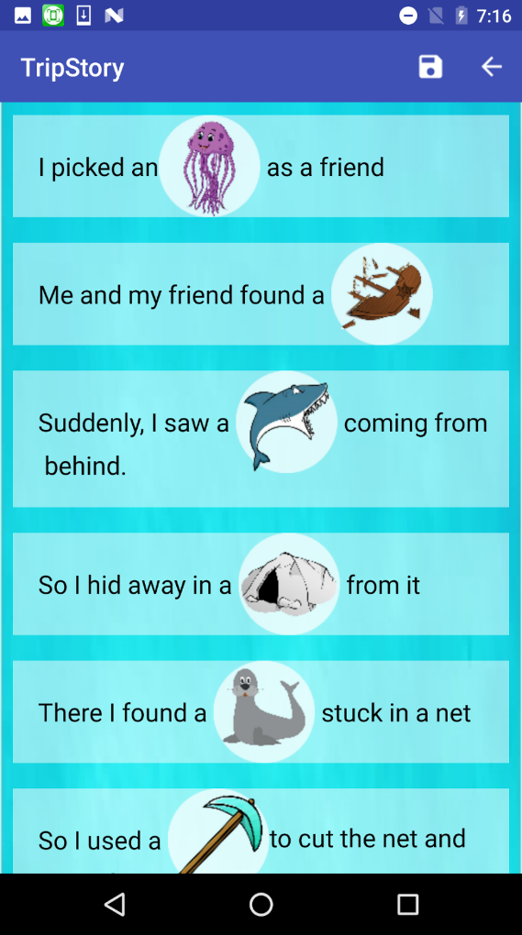

Figure 2.1.5: Screenshot of the Story Compiler

2.1.6 Rebus Story Library:

The Rebus Story Library allows users to read, like and share their creations. The aforementioned options are presented in the form of a Recycler-View which automatically gets updated when a story is created. The Recycler-View is an interactive list which is used to display multiple items in an organized manner while also providing additional functionality such as buttons and a better looking images.

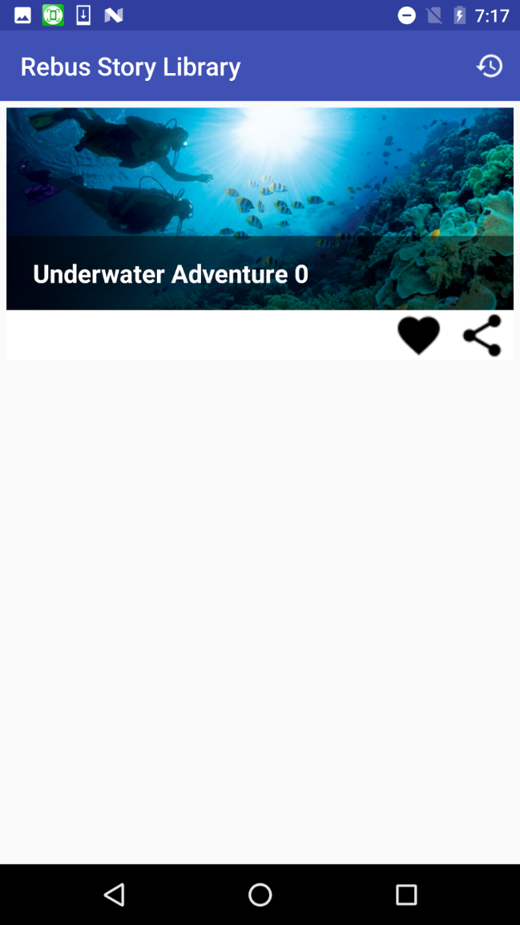

Figure 2.1.6: Screenshot of the Rebus Story Library

2.1.7 Flip View:

Items selected from the Rebus Story Library will launch the Flip View which is an interactive version of the previously generated story. Here, the story appears in the form of a book which the user can flip through to create an authentic reading experience. The view consists of a book cover, an image of the author of the story, and a glossary for reference.

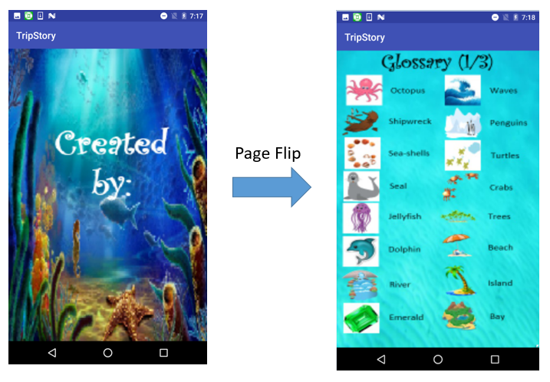

Figure 2.1.7: Screenshot of the Flip View

2.1.8 Animations

Animations were also used throughout the app to provide a more engrossing experience for children. These animations were displayed together with cell phone vibrations to bring each frame to life.

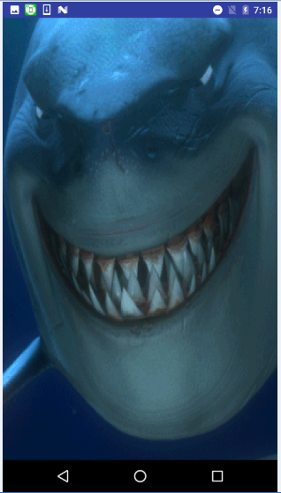

Figure 2.1.8: Animation displayed during frame transition

**What did not work:**

All the spiral goals were achieved and the result was a fully functional final product. Some of the more ambitious tasks that were conceptualized are further discussed in Future Works (Section 6).

3. Overall Design – Block diagram, description of each part

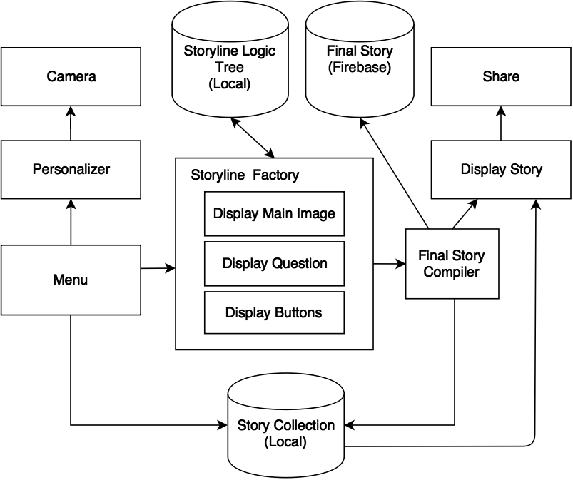

Figure 3.1 Application Block Diagram

The core of the application is the screen that allows the user to create a story by answering series of questions. This screen is called a Storyline Factory and includes the following components: main image, posed question and selection option in the forms of image buttons. The data for these components is stored in local database called Storyline Logic Tree.

Once the story has been created, it is then passed to a Final Story Compiler, which saves the story and displays it in a readable format. When saving, the story is saved in both cloud based storage (Firebase) and local Story Collection database. From Display Story page user can share the story with friends via social media platforms.

A Menu page allows user to navigate through the application. The user can choose to personalize the application by taking a picture, which will be later used throughout story creation process and as a cover page for the final story. The user can also view previously created stories by navigating to Read Created Stories page. This page will pull previously created stories from Story Collection database and display them using Compiler. From this page, user can also choose to share or favorite a particular story.

4. Reflection

4.1 Software:

* During the development of the code it became apparent that the use of Realm and online storage was essential for the purposes of this app because of the length of the story (15 frames) to extend it beyond the existing theme (Underwater Adventure). After some deliberation we decided to further learn about the aforementioned tools for this project.
* In hindsight, this type of application could have also be developed using a cross platform software, such as Phone Gap. Animation could have been incorporated using JavaScript, activity pages replaced with HTML pages and the data would still be stored in Realm and Firebase.

4.2 Specialist:

* Using photographic images instead of animated ones for the App would add to the educational value by presenting the child with real life scenario to better child’s understanding of the world and how it looks like.

5. Individual Contribution

5.1 Ayazhan Zhakhan:

Programmer responsible for the following features in the application:

5.1.1 Storyline Factory

Created Storyline factory by linking images, buttons and question texts from local database with activity.

5.1.2 Story Creation Logic

Designed logic algorithm that links pre stored data with user selections to create personalized story.

5.1.3 Final story compiler

Created Final story compiler that takes newly created story as an array of data from Storyline factory and converts it into readable format and displays it.

5.1.4 GUI design

Designed and created graphical user interface (GUI).

5.2 Shuja Khalid:

Programmer responsible for the following features in the application:

5.2.1 Story Personalizer:

Created this module by launching a camera intent and by subsequently using the captured image throughout the story creation process.

5.2.2 Online Storage:

Implemented an existing online storage system (Firebase) to create a backup of the created stories in the event that the local copy is lost. This feature ensures that the stories, which are a figment of the user’s imagination, can be preserved as they have inherent nostalgic value.

5.2.3 Page Flipper:

Modified an existing library to implement a page flipper animation for the final story. The class within the library would only accept files that existed in the application’s resources folder. This was changed to allow files in the DCIM folder to be displayed.

5.2.4 Transition Animations:

Modified an existing library in order to display animated gif files between story frames.

5.2.5 Rebus Story Library:

Created a Rebus Story library using recycler views to allow users to easily “Like”, “Share” and “View” the stories.

5.2.6 Story Sharing:

Used application “intents” to transfer files between Trip Story and messaging applications to allow for the sharing of stories with friends and family.

5.3 Saher Samnani:

5.3.1 Story (Questions and Images)

Created the stories and provided relevant questions and images for each of the frames in the story

5.3.3 Conducted Research

Surveyed existing applications that serve the same purpose as Trip Story while providing guidance about the Graphical User Interface to enhance the user experience.

**6. Future Work**

A number of ideas were put forth by the group’s specialist that were not implemented in the final version of the App due to time constraints:

6.1 Additional Themes

Providing a continuous flow of stories for Trip Story is extremely important to not only motivate children to continuously enforce good reading habits. This can be achieved by providing periodic updates to the App.

6.2 Audio Clips:

An audio player would allow users to associate the words in the App with what they hear thereby developing not only their reading comprehension but also their listening comprehension skills.

6.3 Additional Animations

Children adore visuals and what better way to engage them in the game and add to their excitement than to have animations that are directly connected to the choices they make?

Small videos or Gif files for each possible selection would accomplish this goal.

6.4 Develop IOs version

Catering to a larger market by making an iOS version will be considered based on the reception that Trip Story receives after it is launched on the Google Play Store.

6.5 Adventure Map

Each story is an adventure that the user journeys through. One way to connect each of the adventures and storylines would be to create an adventure map that charts the progress of the user as they embark on their adventures.

6.6 Sequentially final story (one sentence at a time)

The final compiled story is currently presented in a flippable format that is meant to emulate a short rebus story. Another approach is to have a flippable format with only one sentence on the screen at a time. The Trip Story team believes that both these ways have merit and that there is value in providing the user with both display options.

**7. Group Consent**

7.1. Video of final presentation:

The following members of the group agree to have the video of the final presentation posted on the course website:

* Shuja Khalid
* Ayazhan Zhakhan
* Saher Samnani

7.2. Report:

The following members of the group agree to have the Final Report posted on the course website:

* Shuja Khalid
* Ayazhan Zhakhan
* Saher Samnani

7.3. Source code:

The group is intent on continuing to work on this project and would prefer that it **NOT** be posted to the course website. However, the code will be submitted on portal for review as per the instructions.